The new Alaska NRA license plates
are now available!
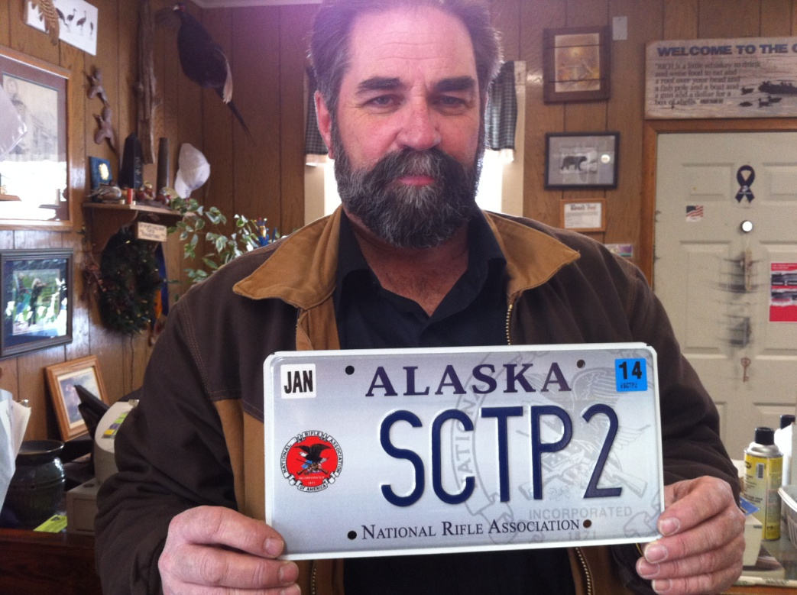
Profits benefit Alaska SCTP youth shotgun teams. You may apply for your NRA license plate online or go to any Alaska DMV office.

https://online.dmv.alaska.gov/dos/PersonalizedPlate/PersonalizedPlate/

